Automated Weather Based Schedule Triggering System
Project Report with Proof of Completion (POC)
Name: LAKSHMI PRIYA A
Register Number: 2403921314922029
Year / Department: 3rd Year CYS
Platform: n8n, CHATGPT,GMAIL
Project: Automated weather based schedule triggering system

1. Objective
The objective of this project is to automate the generation and delivery of personalized, weather-aligned daily study plans. The workflow uses an n8n Schedule Trigger to run automatically, an HTTP Request node to fetch real-time weather data from an API, an AI LLM node (Google Gemini) to analyze the weather and structure a study schedule, and a Gmail node to deliver the final study plan directly to the student's email inbox.
2. Tools and Technologies
- n8n Cloud — Workflow automation, scheduling, and node connection platform.
- Open-Meteo API — Provides real-time weather forecasts (temperature, rain probability, UV index) via HTTP Request.
- Google Gemini Chat Model (AI) — Analyzes weather conditions and generates tailored indoor/outdoor study recommendations and schedules.
- Gmail API / Node — Delivers the generated weather-based study plan directly to the user's email inbox.
3. Workflow Design
The workflow contains four connected nodes operating in the following sequence:
- Schedule Trigger: Automatically starts the workflow at the configured morning schedule interval.
- HTTP Request: Fetches daily weather metrics (temperature, precipitation probability, and UV index) for the selected location.
- Basic LLM Chain (AI Study Planner): Processes the weather data using a customized prompt to recommend whether study sessions should be conducted indoors or outdoors.
- Gmail (Send a Message): Formats and sends the final structured study plan email to the student.
The n8n workflow canvas displays all four nodes connected cleanly with successful execution indicators.
4. Proof of Concept (POC)
- POC 1 — Complete n8n Workflow Canvas: Shows the end-to-end node architecture connected in sequence: Schedule Trigger $→$ HTTP Request $→$ Basic LLM Chain (with Google Gemini Chat Model sub-node) $→$ Send a message (Gmail).
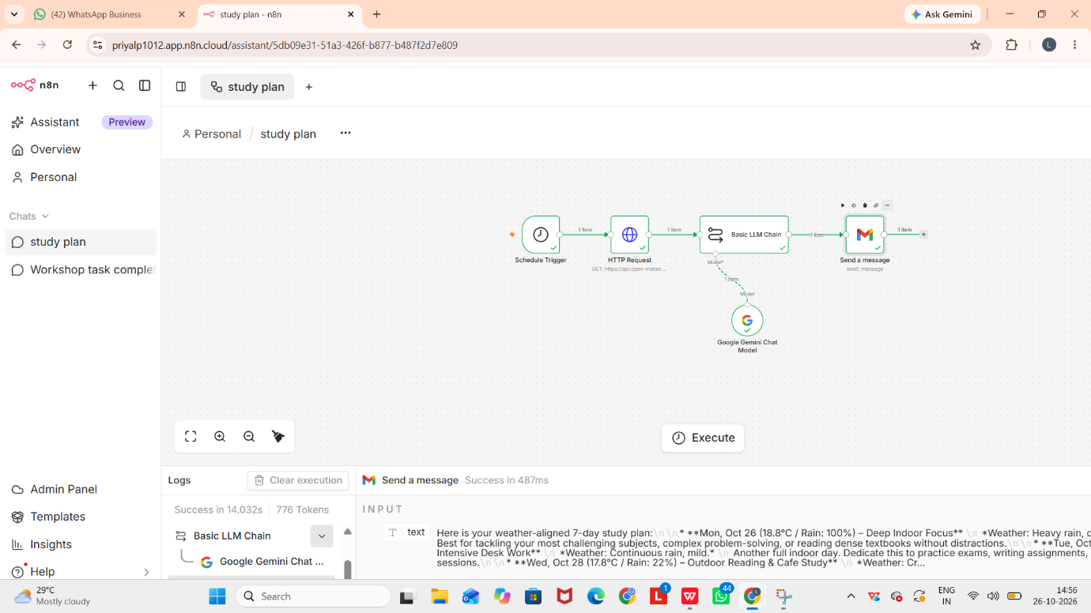

- POC 2 — AI Prompt Configuration: The prompt settings configured inside the Basic LLM Chain, instructing the AI to act as an academic advisor, read the weather variables, and provide structured morning, afternoon, and evening study sessions.

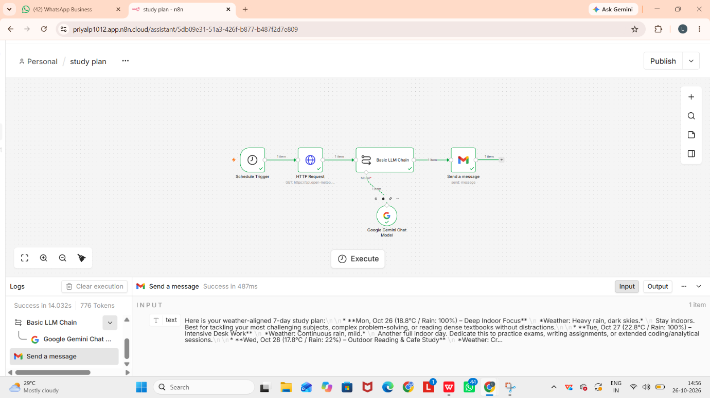
- POC 3 — Successful Execution and Email Delivery: Execution logs showing green checkmarks across all nodes, paired with the received email in the inbox containing the customized weather summary, indoor/outdoor recommendation, and study schedule.

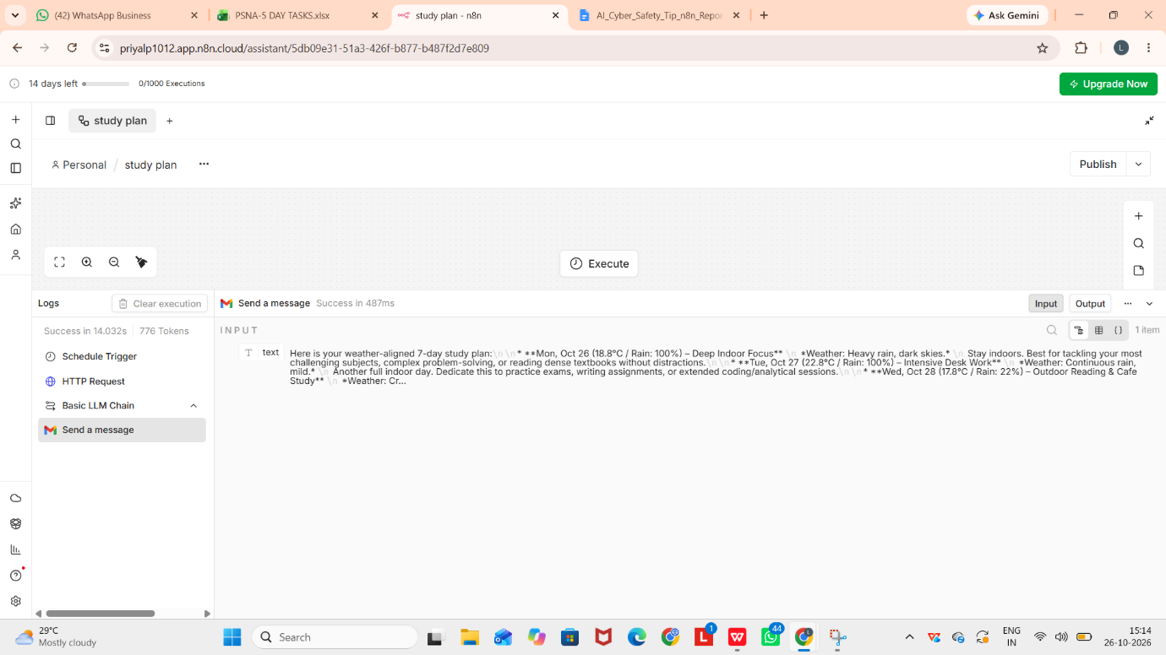
Output :
I received in my mail…..

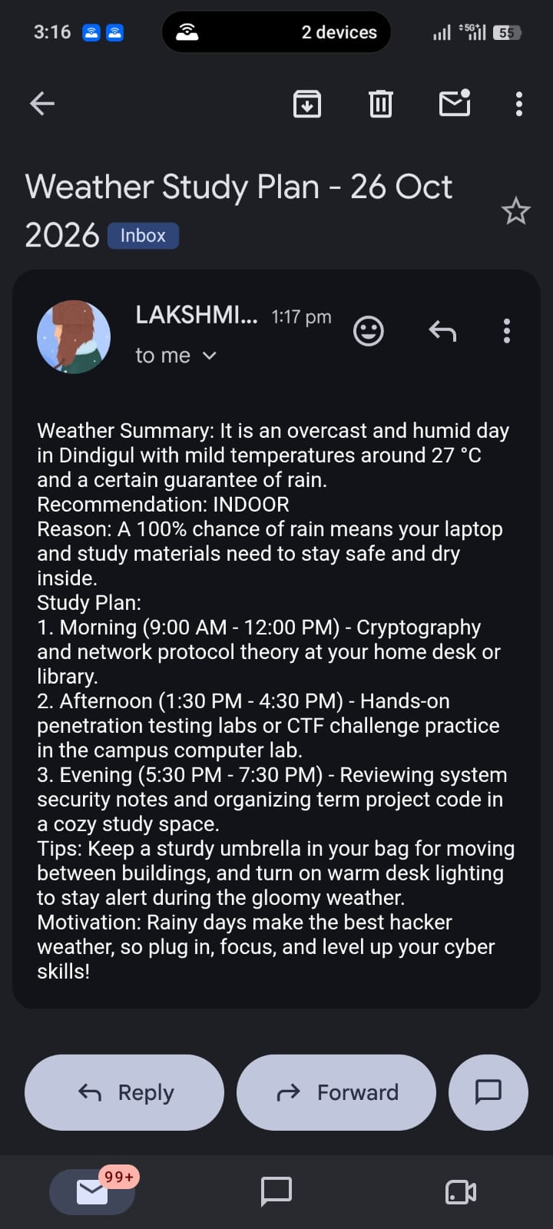
When I changed the input content…..the output will be….
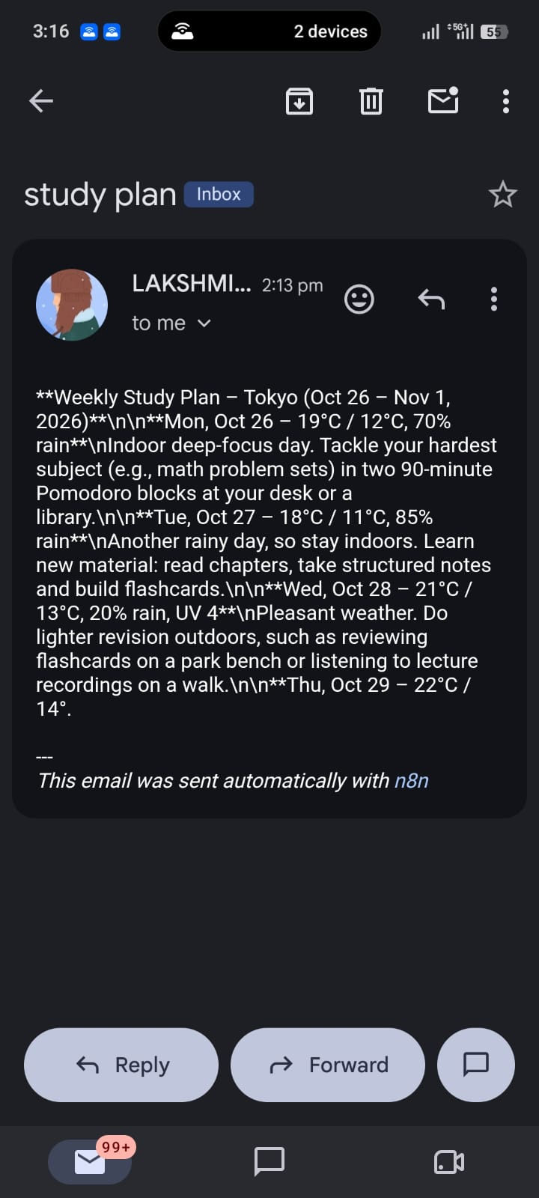

5. Test Results
- Test Scenario 1 (Heavy Rain & High Humidity - 100% Rain): The AI successfully detected heavy rainfall and generated an INDOOR study plan. It recommended focusing on core subjects like cryptography, theory, and lab work indoors, while providing a helpful tip to keep study materials safe and use an umbrella.

- Test Scenario 2 (Pleasant & Mild Weather - 20% Rain, Mild Temp): The AI recognized the pleasant conditions and suggested a hybrid/outdoor plan, recommending outdoor reading on a park bench or listening to lecture recordings during a walk.

- Test Scenario 3 (Hot & High UV Day): The AI successfully handled high temperatures by advising indoor study during peak afternoon hours and shifting any outdoor sessions to early morning or late evening.

6. Conclusion

The Weather Based Schedule Trigger Email workflow successfully automates the retrieval of daily weather data, generates structured academic study plans using AI (Google Gemini), and delivers the final recommendations directly to the student’s Gmail inbox.

The test results and execution logs confirm that the workflow dynamically adapts study recommendations based on changing weather conditions (such as indoor study during heavy rain vs. outdoor revision during pleasant weather). The included screenshots provide proof of the workflow architecture, prompt configuration, successful execution, and email delivery.

7. Submission Checklist

Workflow Naming: Saved workflow using the required naming structure (`RollNo_YourName_Topic`).
Node Customization: Renamed all 4 nodes clearly (`Schedule Trigger`, `HTTP Request`, `Basic LLM Chain`, `Send a message`).
Proof of Completion (POC 1): Captured full workflow canvas with all nodes connected and showing green ticks.

Proof of Completion (POC 2): Captured AI prompt configuration inside the LLM Chain node.
Proof of Completion (POC 3): Captured successful node execution logs and the received Gmail study plan email.
Workflow Export: Exported the completed workflow as a `.json` file for submission.
Google Drive Upload: Uploaded the project report, screenshots, and `.json` file to Google Drive and verified public/view permissions.
Here are the Additional Technical Details formatted to match your project report structure:

8. Implementation Procedure
- Create Workflow: Open n8n Cloud and create a new workflow following the standard naming convention (RollNo_YourName_Topic).
- Add Schedule Trigger: Add a Schedule Trigger node and configure it to run daily at the desired morning hour.
- Add HTTP Request (Weather API): Configure an HTTP Request node using the GET method with the Open-Meteo API endpoint, specifying latitude, longitude, and daily forecast parameters (temperature, rain probability, UV index).
- Add AI Node Chain: Connect a Basic LLM Chain node attached to a Google Gemini Chat Model sub-node. Write the customized prompt using expressions to parse weather data dynamically (e.g., {{ $json.daily.temperature_2m_max[0] }}).

- Add Gmail Node: Add a Gmail node configured with the Send a message action. Connect your Google OAuth credentials, enter the recipient email address, and map the message body to the AI output expression ({{ $json.text }}).
- Test and Verify: Execute the workflow manually to verify that all nodes show green checkmarks and the email arrives successfully in your inbox.

9. Security and Reliability Considerations
- Credential Privacy: Keep Google OAuth credentials, email addresses, and API tokens private; never expose secrets or personal login details in screenshots or reports.
- Recipient Verification: Verify the recipient email address in the Gmail node before activating the workflow to ensure notifications go to the correct inbox.
- Execution Monitoring: Regularly review n8n execution history logs to catch potential network timeouts or failed API calls.
- Timezone Accuracy: Confirm the workflow schedule and timezone settings so that automated study plan emails arrive precisely at the intended local morning time.
- Content Validation: Periodically review AI-generated output to ensure the study recommendations remain practical and clear.

10. Limitations and Future Enhancements
- Fixed Location Coordinates: The current implementation relies on hardcoded latitude and longitude coordinates for a specific city; a future enhancement could dynamically pull coordinates from a user profile sheet or form input.
- Multi-Channel Delivery: The workflow currently sends notifications exclusively via Gmail; future versions could integrate Telegram or WhatsApp notifications simultaneously.
- Error Handling Branch: Adding an n8n error-handling branch or fallback notification channel can ensure alerts are sent if the weather API or AI model experiences downtime.

Appendix A — Configuration Summary
- Workflow Name: RollNo_YourName_WeatherStudyPlan
- Trigger Type: Schedule Trigger (Daily interval)
- Data Source: Open-Meteo Weather API (temperature_2m_max, temperature_2m_min, precipitation_probability_max, uv_index_max)
- AI Model: Google Gemini Chat Model via Basic LLM Chain
- Output Node: Gmail (Send a message)
- Message Expression Mapping: {{ $json.text }}

